TASK 1:
.data
;lab 3 - Task 01
val1 SWORD ?
val2 SBYTE -11
TASK 2:
;lab 3 - TAsk 02
; 2^31 = 2147483648
val3 SDWORD -2147483648

.code
main PROC

mov eax, val3
call writeint
OUTPUT:
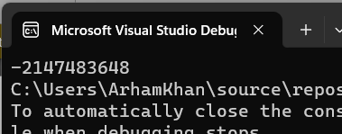
TASK 3:
;lab 3 - TASK 03
Favcolor BYTE "Orange", 0
A WORD 12
B WORD 2
C WORD 13
D WORD 8
E WORD 14
TASK 4:
.data
; the letter ‘c’ was giving syntax error so ‘e’ is used instead
;lab 3 - Task 04
a DWORD 11h
b DWORD 10h
e DWORD 30h
d DWORD 40h
.code
main PROC

mov eax, 0
mov ebx, 0
mov ebx, a
add ebx, b

mov eax, a
sub eax, b

sub eax, ebx

add ebx, e
add ebx, d
mov eax, ebx
call writedec
OUTPUT:
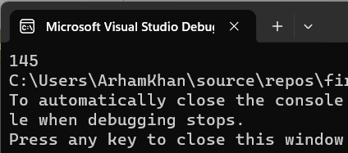

TASK 5:
.data

;lab 3 - Task 05
a BYTE 00010001b
b BYTE 00010000b
e BYTE 00110000b
d BYTE 01000000b

.code
main PROC

mov eax, 0
mov ebx, 0
movzx eax, a
movzx ebx, b
add ebx, eax

movzx eax, a
movzx ecx, b
sub eax, ecx

sub ebx, eax

movzx ecx, e
add ebx, ecx

movzx edx, d
add ebx, edx

mov eax, ebx
call writedec

OUTPUT:
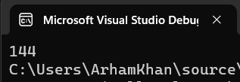
TASK 6:
.data
;Lab 03 - Task 06
wArray WORD 13d, 14d, 16d
TASK 7:
;lab 03 - Task 07
uninitArr DWORD 50 DUP(?)
TASK 8:
;lab 03 - Task 08
testString BYTE "TEST", 0
repTest BYTE 500 DUP('TEST')
TASK 9:
INCLUDE Irvine32.inc
.data
;lab 03 - Task 9
bArray BYTE 20 dup(0)

